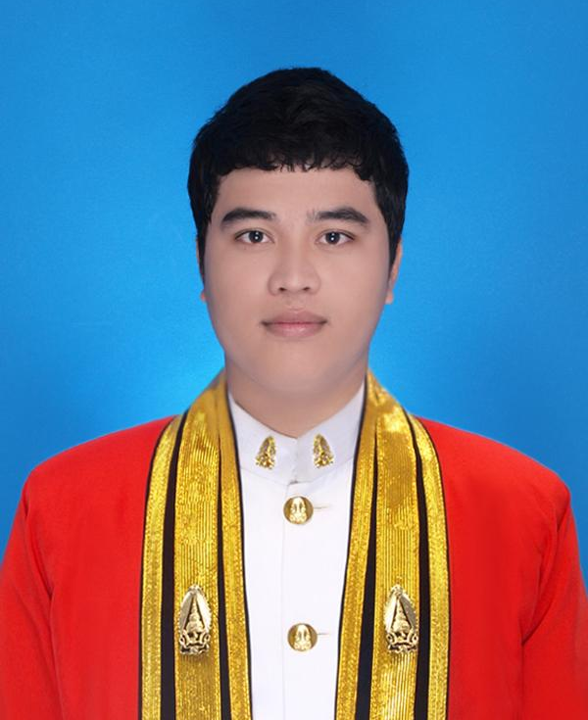
Personal Information

Name : Wirat Pantayung

Nickname: Louis

Date of Birth : December 18, 1988.

Mobile : 083-050-3557

E-Mail : wirat.31@hotmail.com

Height : 168
Weight : 80

GENDER: Male.
Marital Status : Single.

Nationality : Thai.

Religion : Buddhism.

Military : Exempted.

Health : Good.

Address : 19 Sukhumvit 27, Sukhumvit Road, Klong Toey Nua, Wattana, Bangkok 10110.

Education

2010-2011 Bachelor Degree of Industrial Technology.
Major Information Technology.
King Mongkut's University Of Technology North Bangkok.
GPA 2.81
2008-2009 High vocational of Information Technology.
Surin vocational collage.
GPA 3.50
2005-2007 Vocational of Business Computer.
Surin vocational collage.
GPA 3.33

Employment History
1.) Motif Technology PLC. Bangkok, Thailand June 2011 – October 2012.
- Software Engineer (June 2011 – October 2012).

Project Involved

As a Software Engineer
- Social Security Office.
Project: Social Security System.

- Provincial Electricity Authority.
Project: e-ONE Portal Service and Enterprise Application integration System.
- Siam Commercial Bank.
Project: Professional Services for Software Development in Loan Origination Project.

2.) Krung Thai Computer Services PLC. Bangkok, Thailand November 2012 – MARCH 2015.
- Java Programmer (November 2012 – March2015).

Project Involved

As a Java Programmer
- Krung Thai bank.
Project: Image Cheques Clearing And Archive System (ICAS)

- Krung Thai bank.
Project: Signature for ICAS.

- Krung Thai bank.
Project: Physical Cheques Inventory.

3.) Krung Thai Bank. Bangkok, Thailand MARCH 2015 – present.

Project Involved

As a Java Programmer
- Krung Thai bank.
Project: Image Cheques Clearing And Archive System (ICAS). (Continue)

- Krung Thai bank.
Project: Signature for ICAS. (Continue)

- Krung Thai bank.
Project: Physical Cheques Inventory. (Continue)

Technical Skills

Programming Languages | Java / JSP / HTML / JavaScript / jQuery / C++ / PHP / ABAP+SAP.
Database | Microsoft SQL Server 2012 / MySQL / Oracle / IBM DB2 /PL SQL.
Web Server | Jakarta Tomcat / Microsoft IIS / IBM Web sphere.
Java Technology | Struts / Struts2 / Hibernate / Spring.
Application Server | JBoss 5 / Apache Tomcat.
Work Operating systems | Windows XP / Windows 7 / Linux / Ubuntu.
Office Tools  Software tools | Microsoft Office Word / Excel / PowerPoint / Access / Visio.  Eclipse / Adobe Dreamweaver / Visual Studio / Net beans.
Other Knowledge | Adobe Dreamweaver / Photoshop /Flash / illustrator etc.

Languages Skill English: Speak Fair
Read Good
Write Fair
Thai: Speak Good
Read Good
Write Good

Typing Thai: 40 Word/Min.
English: 45 Word/Min.

Expected Salary 60,000 Baht/Month Up.

Project Work

Title: Computer Service Online System.

Environment: Adobe Dreamweaver, PHP Language, MySQL, JavaScript, jQuery.

Description: For Prachin buri Technical College.

References

Prof. Dr. Yupin Supakoon.

Information Technology.

King Mongkut's University Of Technology North Bangkok.

Tel. 0-3721-7300 Fax. 0-3721-7329.

************************************

